1. Install nginx and run nginx on port number 82

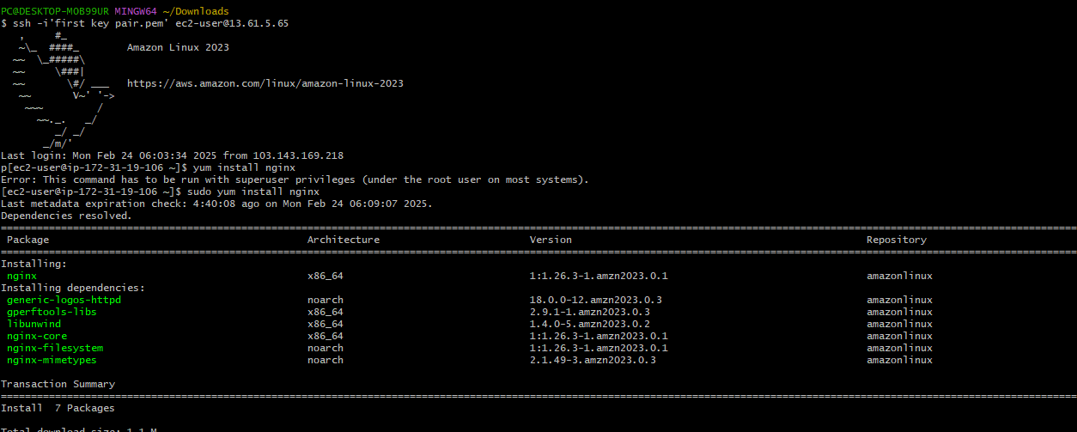

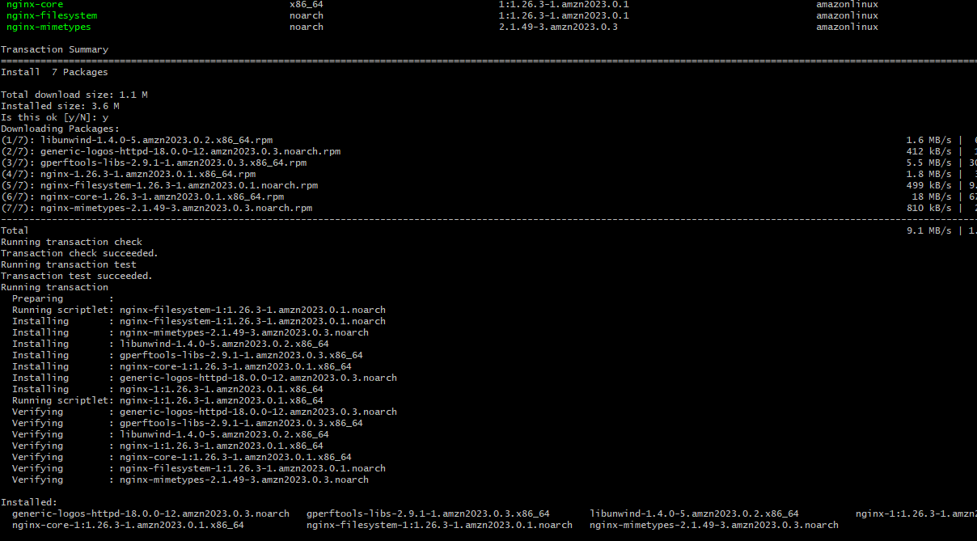

**Now check the service status, is it running or not using “ systemctl status nginx ” command**

**and if not Active , start the service and again recheck the status**

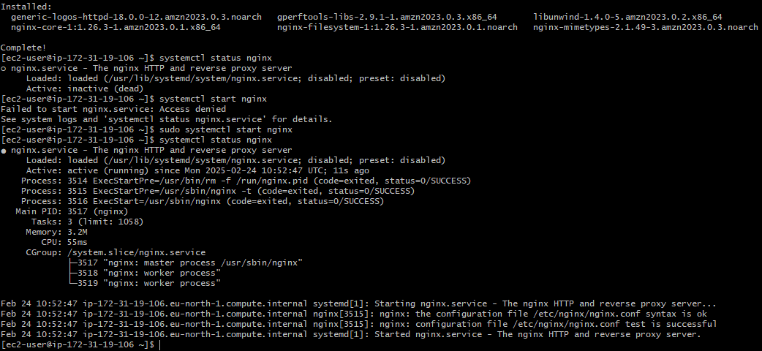

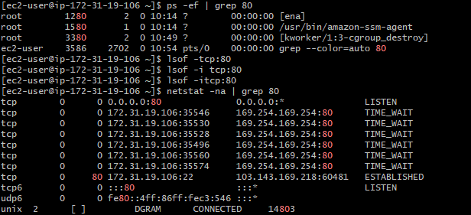

**Check on the browser also**



**Change port number 80 to 82 : before editing port number try to keep one backup file**

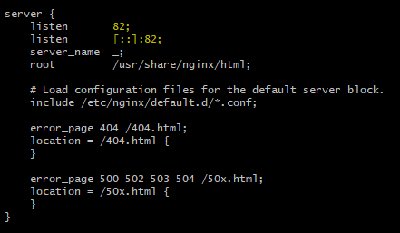

**Now check the service status, is it running or not using “ systemctl status nginx ” command, and if status is not Active , start the service and again recheck the status**

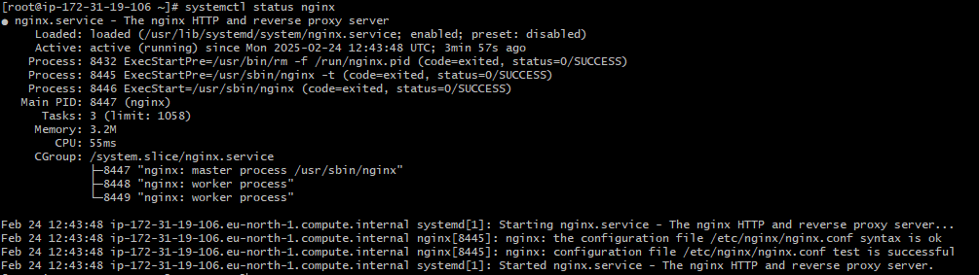

**Now check service running or not using “port number 82”**

 **Also check using “port number80”,you will get nothing Listening on this port number**

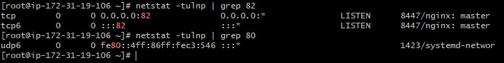

**Check on the browser also**

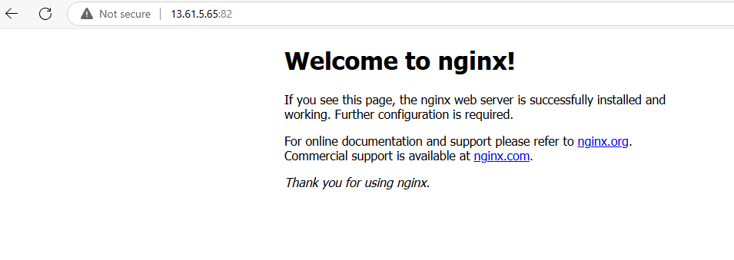

1. Deploy a sample index.html file on nginx



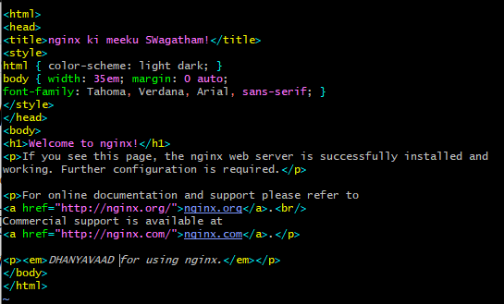



1. **Install Apache and run Apache on port number 81.**

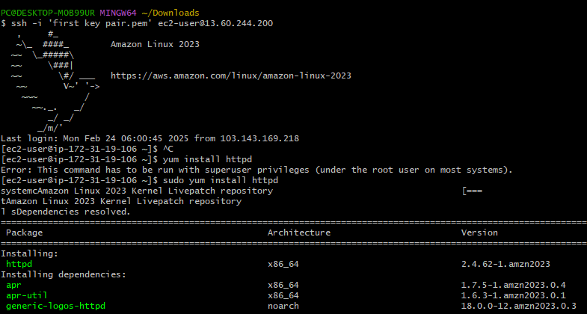

**Check the service status and if not Active , start the service and again recheck the status**

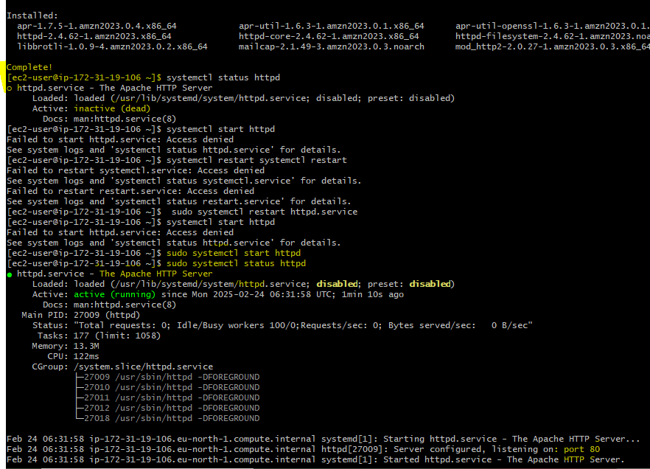

**Check service running or not using port number**

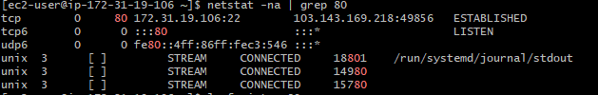



**Check on the browser also**



**Change port number “ 80 to 81 ”**

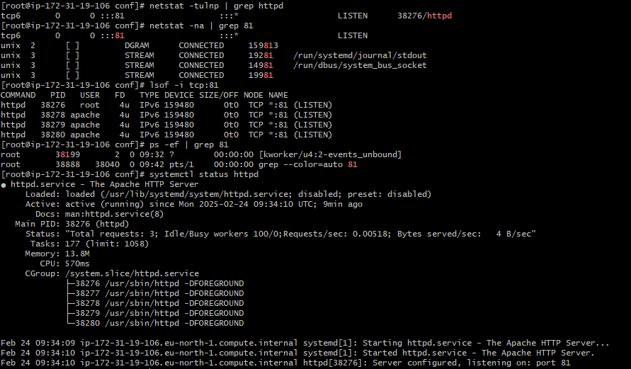



**4**) Deploy a sample index.html file on Apache

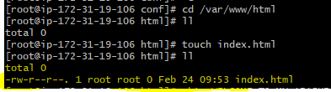





1. **Install Apache Tomcat on port number 8082**

First connect to the remote server using ssh, key pair and public IP address

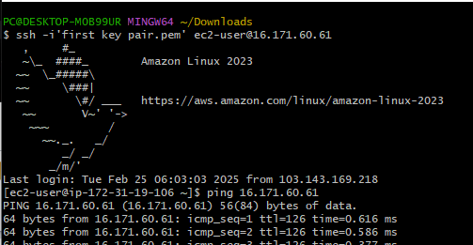

Check Java version if exists ,if not install Java using “yum install java ” command , because “Java” is the prerequisite for Apache Tomcat ,why because it is developed in Java programming language.

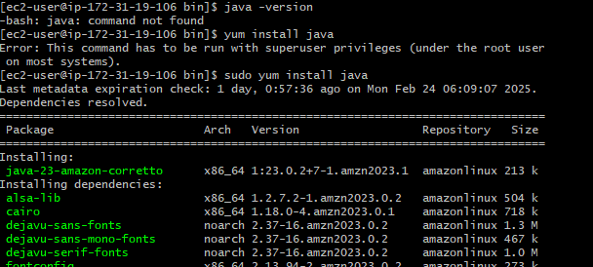

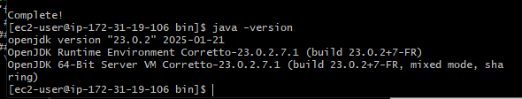

Now install Tomcat using wget , because we are unable to install using “yum” package, So go to browser and select latest version of Apache tomcat and copy that link. By using “wget” command followed by this link we can install Apache tomcat

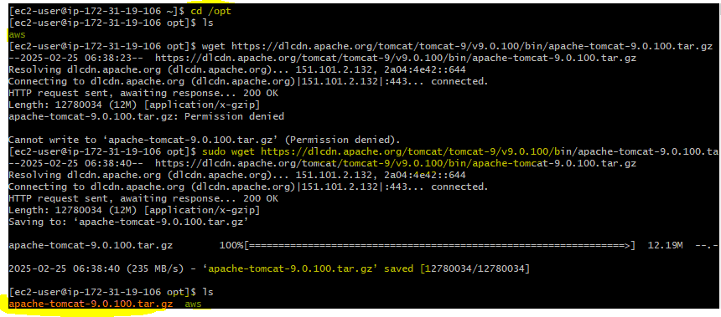

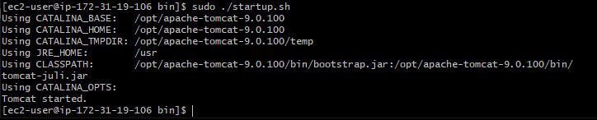

U will get 1 tar file downloaded and untar it





**Now change to bin directory and yo will get .sh files ,by using startup.sh start Apache tomcat**

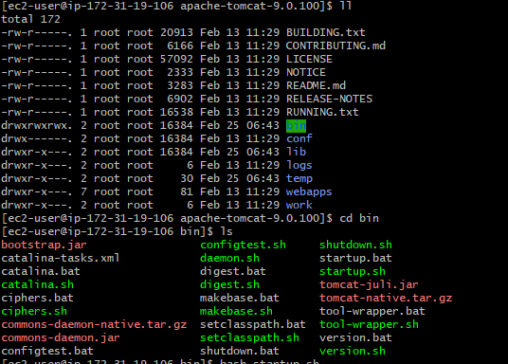

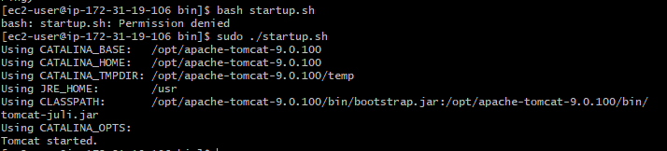

**Now check status of tomcat service running or not using port number**

**We can not use systemctl status tomcat ,why because we are not installing tomcat using “yum” repository / packager.**

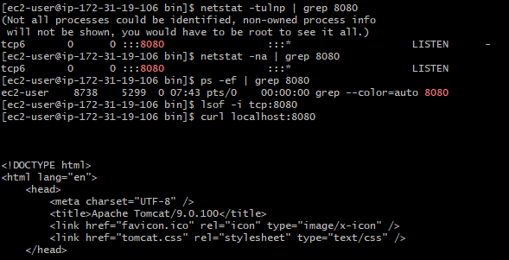

**We can check logs also by logs file**

**Default file location of Tomcat logs : Catalina.out**

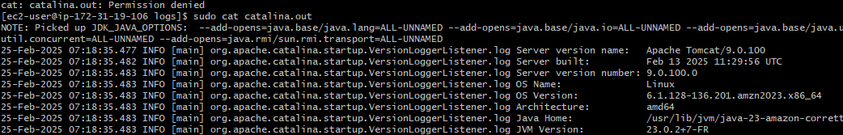

**Now access tomcat on the browser**

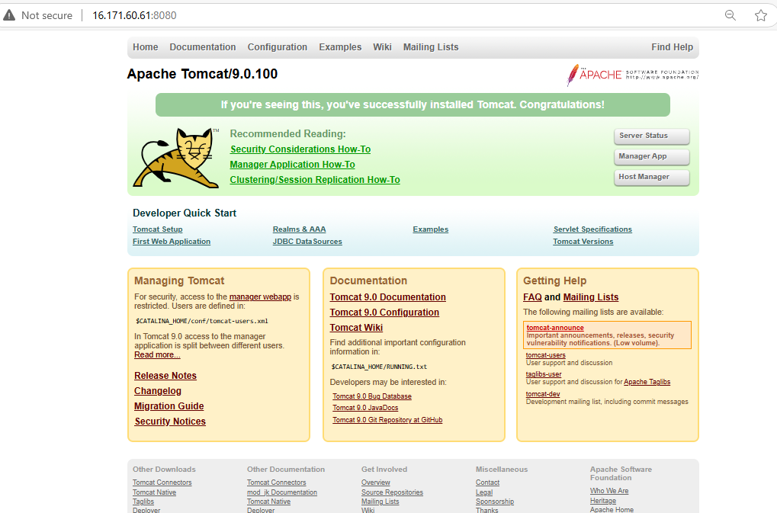

**Now change the port number to 8082 ,**

**Before editing first we need to the Shutdown the tomcat using “./shutdown.sh”**

**To change the port number Go to conf folder ,there you will get server.xml file ,edit the content using “ vi ” command ,and replace port number 8080 with 8082.**

**Now we can restart the tomcat using “ ./startup.sh”,service will restarts .**

**Go to the browser and check “ IP address:8082”.**

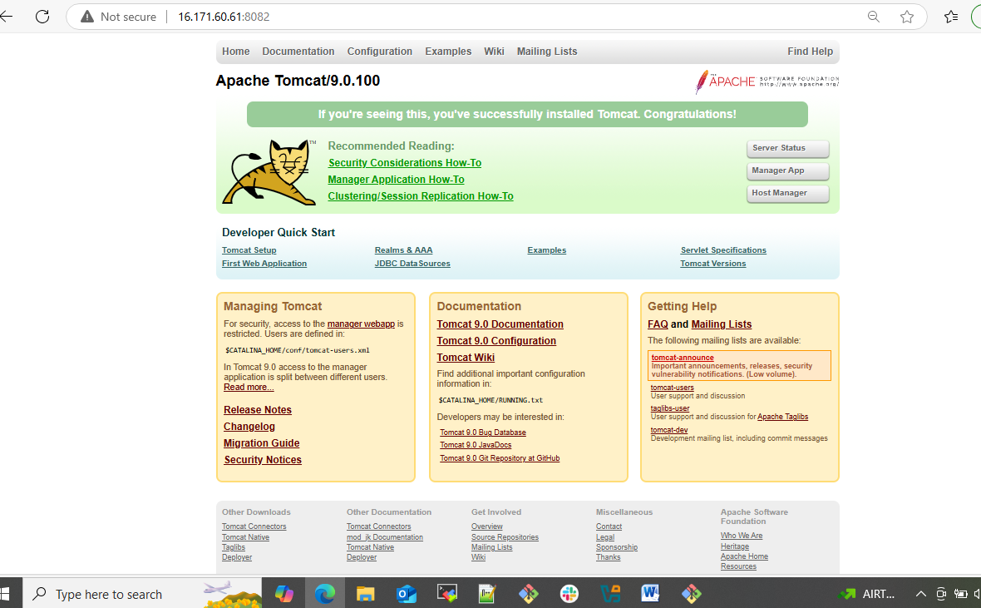

**6 )Deploy a sample app on webapps :-**

**First,go to the browser and copy link of 1 Apache tomcat tar.gz file**

**And in Git bash Change to /opt directory and download the Apache tomcat using wget command followed by link (copied)**

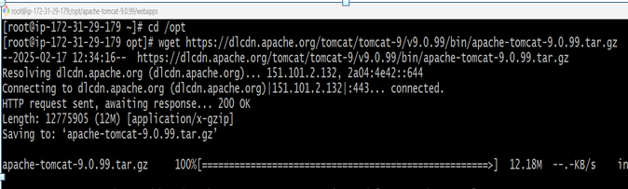

**Now untar the zip file using “ tar xvf ” command**



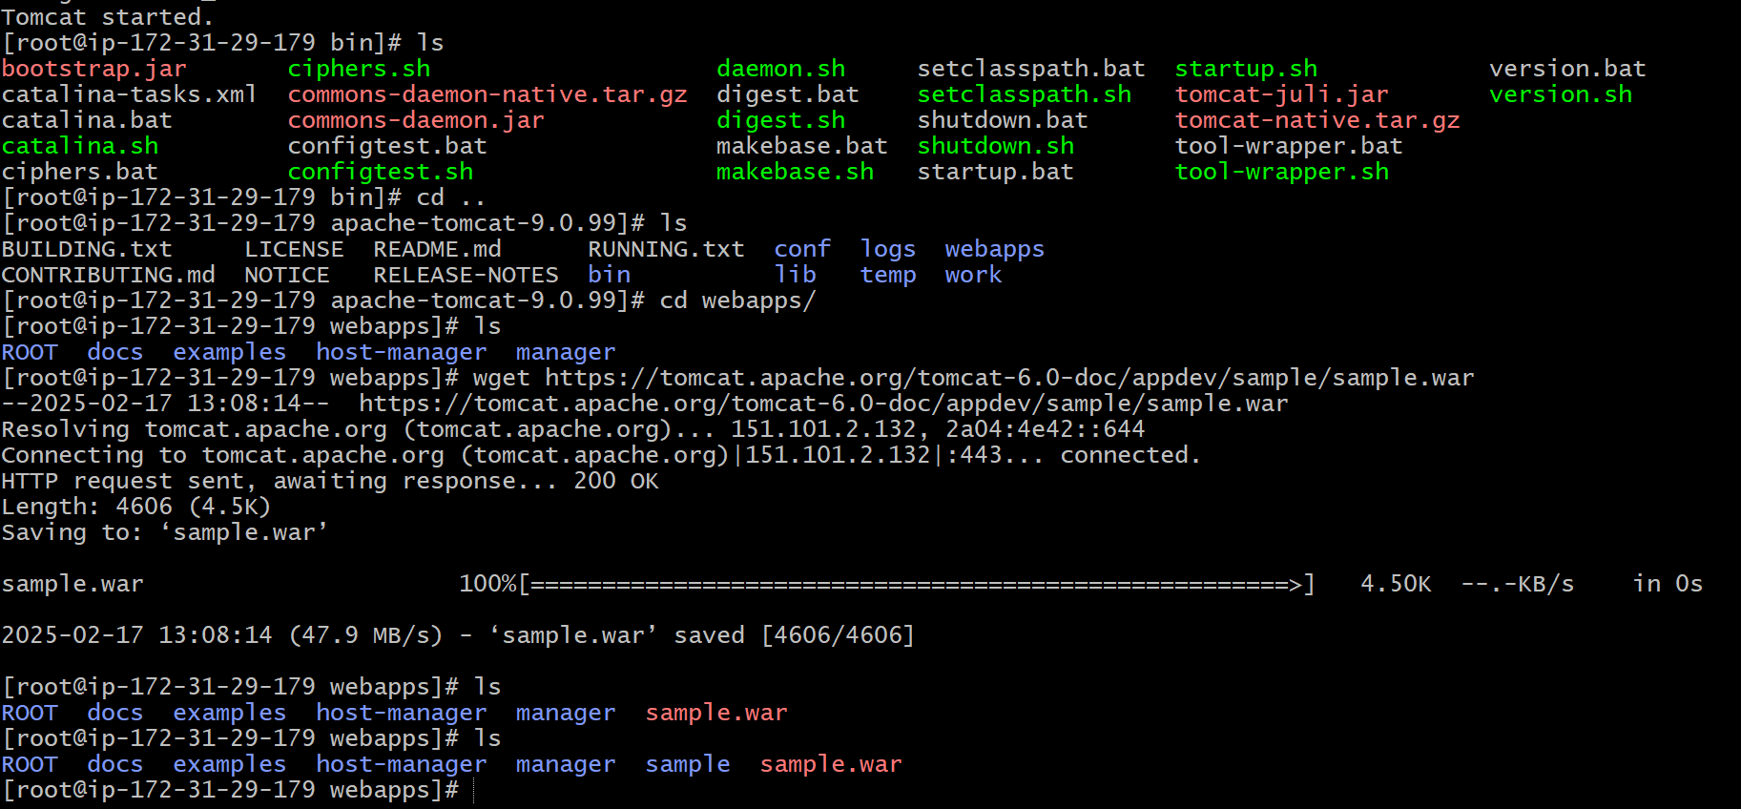

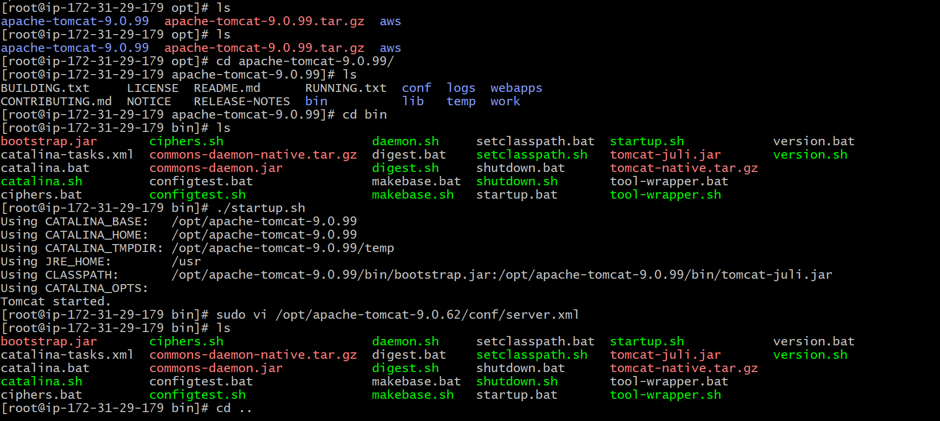

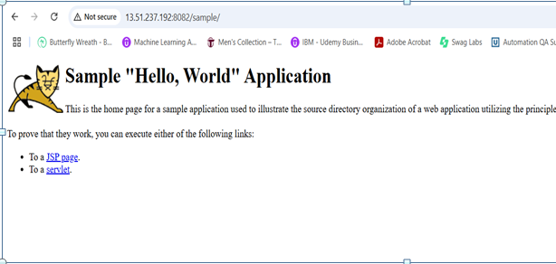

1. **Create a tomcat.service file for tomcat**

**Go to /etc/systemd/system**

**Create 1 file with tomcat.service , and paste the below script and save**

[Unit]

Description=Apache Tomcat Web Application Container

After=syslog.target network.target

[Service]

Type=forking

User=tomcat

Group=tomcat

Environment=JAVA_HOME=/usr/lib/jvm/jre

Environment=CATALINA_PID=/opt/apache-tomcat-8.5.6/temp/tomcat.pid

Environment=CATALINA_HOME=/opt/apache-tomcat-8.5.6

Environment=CATALINA_BASE=/opt/apache-tomcat-8.5.6

Environment=CATALINA_OPTS=

Environment="JAVA_OPTS=-Dfile.encoding=UTF-8 -Dnet.sf.ehcache.skipUpdateCheck=true \

-XX:+UseConcMarkSweepGC -XX:+CMSClassUnloadingEnabled \

-XX:+UseParNewGC -Xms2g -Xmx4g"

ExecStart=/opt/apache-tomcat-8.5.6/bin/startup.sh

ExecStop=/bin/kill -15 $MAINPID

[Install]

WantedBy=multi-user.target

**And once saved the content reload and enable the service**

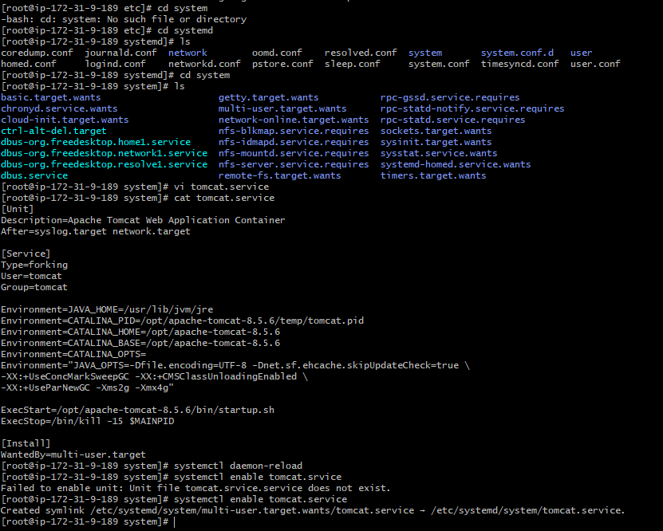

**8)Configure HA proxy server**

**First of all, create 3 instances : server 1 ,server 2 and HA proxy**

**In server 1 we will install httpd , in server 2 we will install nginx and in server 3 we will install HA proxy**

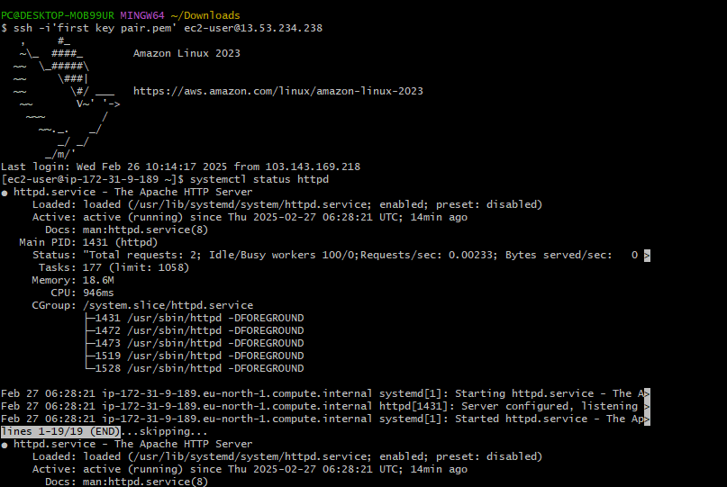

**In server2 we will install nginx**

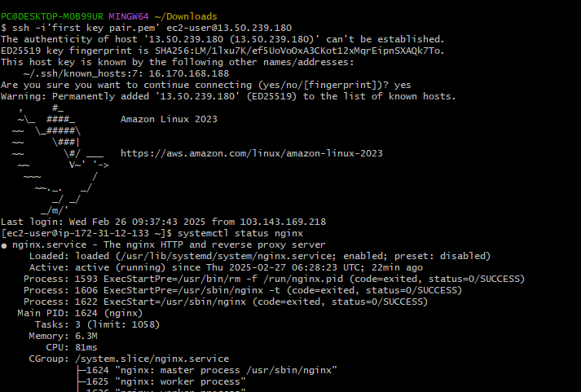

**In server 3 we will run HA proxy**

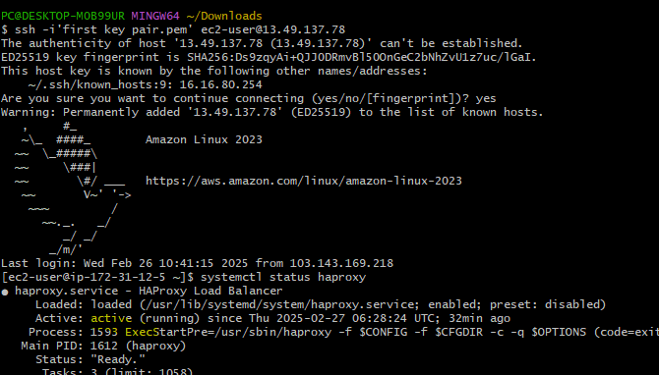

**Vi /etc/hosts**

**Add HA proxy server public IP address in httpd server hosts file as well as nginx also and ping that load balancers using**

**Ping load_balancer -c 4**

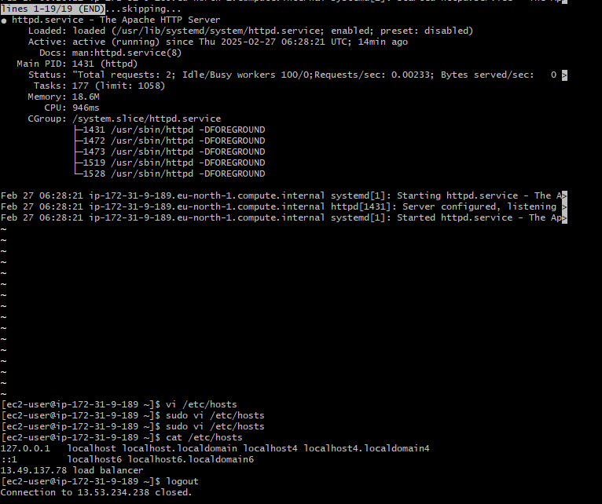

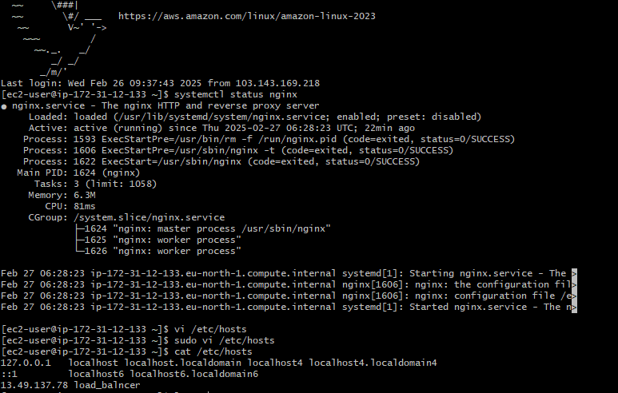

**Now in HA proxy server host files add server1 and server2 IP addresses and ping that load balancer using**

**Ping load_balancer -c 4**

**When we check on the browser it will show httpd when we refresh it it will show nginx**



